**Saarinen, Eero (1910-1961)**

Michael Johnson, Northumbria University

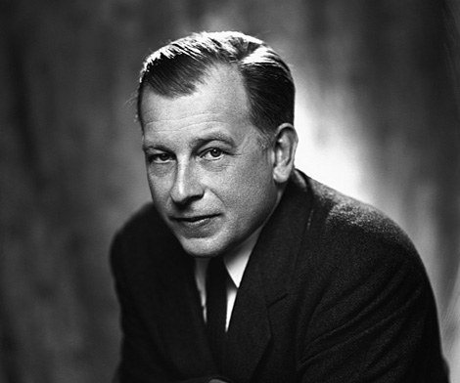

Eero Saarinen

<http://www.cadesign.ie/assets/images/uploads/designers/large/eero-saarinen.jpg>

Eero Saarinen was the son of influential Finnish architect Eliel Saarinen and followed his father into the architectural profession. In his own right, he pioneered a fluid approach to modern architecture and furniture design in the post-war period. Saarinen extended the modernist vocabulary with flowing curves, interpenetrating spaces, and biomorphic forms, earning a reputation as a ‘structural expressionist’. His architectural works display variety and structural experimentation, with parabolic curves in steel or concrete, while his furniture design exploits the properties of plastic to create organic shapes and saturated colours.

Eero Saarinen was born on his father's 37th birthday. The family immigrated to the USA in 1923, and the elder Saarinen took up a teaching position at the Cranbrook Academy of Art in Michigan. Eero Saarinen worked with fellow students Charles and Ray Eames, as well as Florence Schust, the future wife of furniture manufacturer Hans Knoll, with whom Saarinen collaborated in later life.

Saarinen studied sculpture at the Académie de la Grande Chaumière in Paris, before completing his education at the Yale School of Architecture from 1931-34. After extensive travel and a year in his native Finland, he returned to Cranbrook to work and teach alongside his father. He became a naturalized citizen of the United States in 1940. During the Second World War, Saarinen was recruited by Donal McLaughlin, a fellow alumnus of the Yale School of Architecture, to work for the Office of Strategic Services (OSS). In this role, he drew illustrations for bomb disposal manuals and provided designs for the Situation Room of the White House.

While still working for his father, Saarinen received recognition for a chair designed in collaboration with Charles Eames for the ‘Organic Design in Home Furnishings’ competition (1940). Further attention came when Saarinen won first prize in the 1948 competition for the design of the Jefferson National Expansion Memorial in St Louis, Missouri, although the award was mistakenly sent to his father. The monument, which was not completed until the 1960s, takes the form of a stainless steel parabolic arch.

Saarinen’s work informed the idiom now known as Mid-Century Modern, an attempt to adapt European modernist aesthetics to American commercial and domestic needs. During a long association with the Knoll furniture company, founded by Hans Knoll, he designed many important pieces of furniture, including the Grasshopper lounge chair (1946), with its cantilevered supports of bent laminated wood, and the Womb chair (1948), designed at Florence Knoll’s request for a ‘chair that was like a basket full of pillows – something she could really curl up in’ (<http://www.knoll.com/product/womb-chair>).

Saarinen was one of many designers of this era who experimented with the fluid possibilities of plastic and fibreglass. His famous Tulip chair (1956) grew out of attempts to produce a chair as a single unit; in practice the base had to be cast in aluminum, while the upper shell was moulded in fiberglass with a plastic finish. With its fluid form, the chair anticipated the pop design of the 1960s. Indeed, a modified version featured in the TV series *Star Trek* (1966-69).

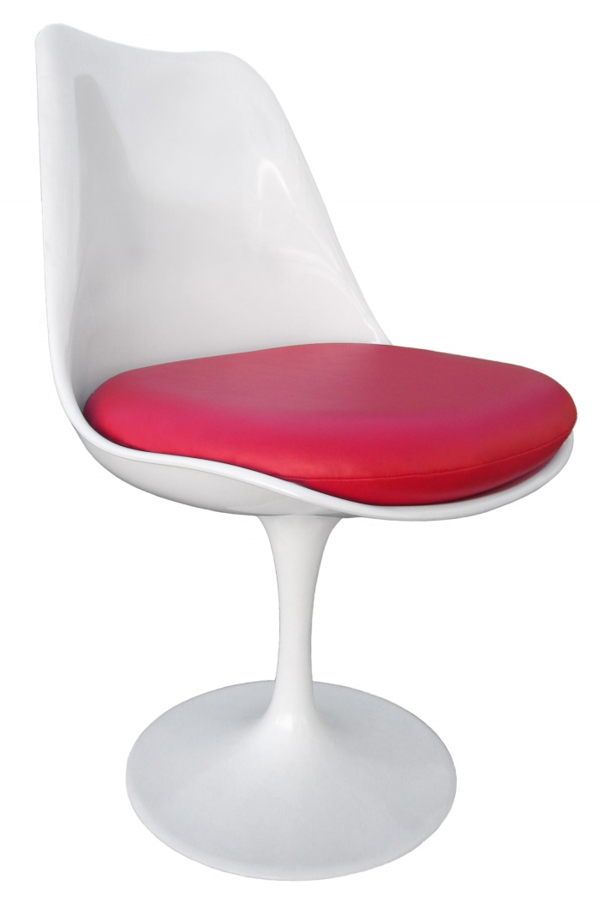

Tulip Chair (1956)

<https://walbea.files.wordpress.com/2013/04/redsidecushion-chair45degree-white1.jpg>

After his father's death in 1950, Saarinen founded his own architectural practice, Eero Saarinen and Associates. The first major work by Saarinen was the General Motors Technical Center in Warren, Michigan (1956). This industrial complex followed the severe rationalism of Mies van der Rohe’s work, incorporating rectangular forms in steel and glass, but it also featured a circular auditorium with an aluminium dome and a striking water tower. Following the success of this project, Saarinen was invited to design headquarters for major American corporations such as John Deere and IBM. Although outwardly rationalist, the interiors feature dramatic sweeping staircases, as well as Saarinen’s fluidly-styled furniture.

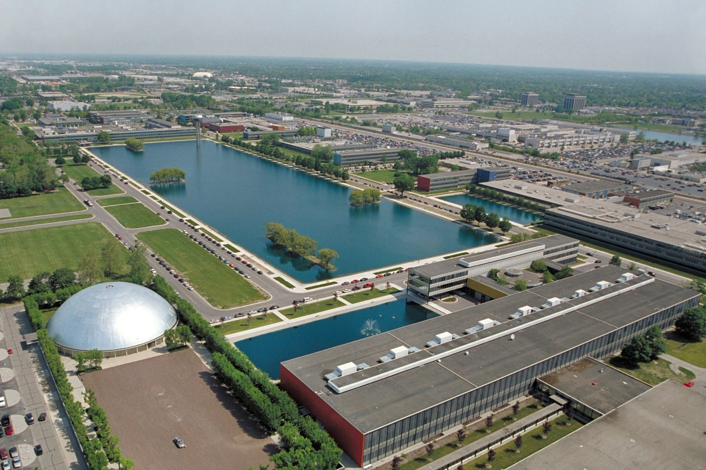

General Motors Technical Center, Warren, Michigan (1948-57)

<https://fastlane.gm.com/wp-content/uploads/2014/11/tech-center.jpg>

In the 1950s Saarinen undertook numerous commissions for university campuses. Notable works include the Emma Hartman Noyes dormitory at Vassar and the David S. Ingalls Ice Hockey Rink at Yale University. Known as ‘the whale’, the rink is a thin-shell structure with suspension cables connected to an arching concrete spine. The same system was used for the Kresge Auditorium at the Massachusetts Institute of Technology, an extremely elegant shell of reinforced concrete, sliced away by sheer glass walls. The neighbouring MIT Chapel (1955) is a robust cylinder in textured brick. Internally, undulating brick walls create a chamber of mystic quiet and a column of light plunges down from the circular skylight, reflecting against a metallic sculpture by Harry Bertoia.

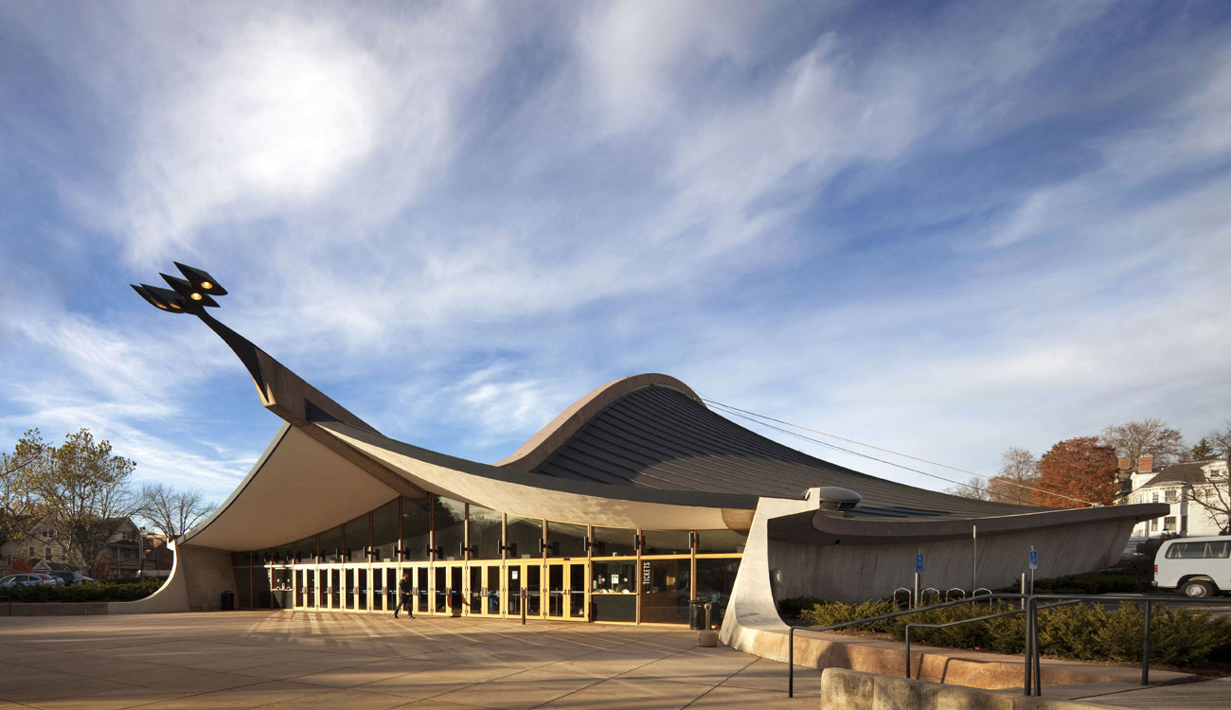

David S. Ingalls Rink, New Haven, Connecticut (1956-58)

<http://www.krjda.com/Images/Ingalls%20Images/Ingalls-rink%202.jpg>

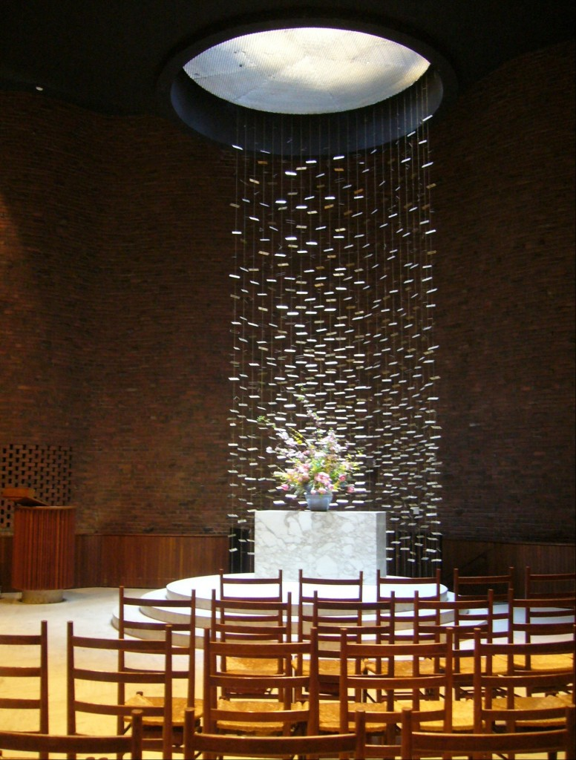

MIT Chapel, Cambridge, Massachusetts (1955)

<http://transienttravels.com/wp-content/uploads/2009/03/mit-chapel-776x1024.jpg>

Many of these projects use catenary curves, the shape that a hanging cable assumes when supported at both ends. Significantly, Saarinen served on the jury for the Sydney Opera House competition and was crucial in the selection of Jørn Utzon’s design, which recalled his own shell-like forms, but which had previously been discarded by the judges. The culmination of Saarinen’s work is the Trans-World Airline Flight Center at John F. Kennedy International Airport, with its outward-sweeping arches symbolic of flight and an almost Gaudiesque play of curves within. Saarinen died while undergoing an operation for a brain tumor at the age of 51.

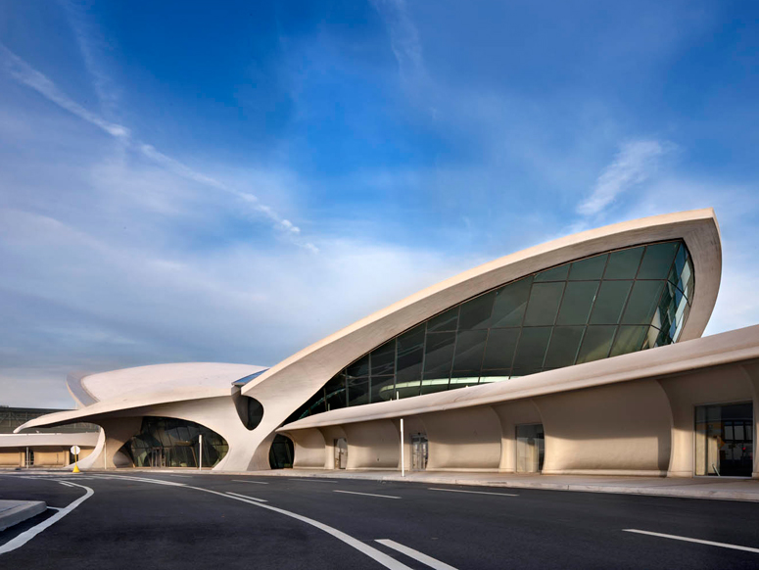

TWA Terminal, New York City, New York (1956-62)

<http://photos.cntraveler.com/2014/07/31/53da51fadcd5888e145ada56_twa-terminal-nyc-architecture-trends.jpg>

**Selected Works**

|  |
| --- |
| 1938-42 Crow Island School, Winnetka, Illinois |
|  |
| 1944-48 Des Moines Art Center, Des Moines, Iowa |
| 1945-57 Drake University plan and buildings, Des Moines, Iowa |
|  |
| 1947-49 Christ Church Lutheran, Minneapolis, Minnesota |
| 1947-59 Eero Saarinen House, Bloomfield Hills, Michigan |
| 1947-65 Jefferson National Expansion Memorial, St Louis, Missouri |
| 1948-57 General Motors Technical Center, Warren, Michigan |
| 1949 Aspen Music Center, Aspen, Colorado |
| 1949-52 Brandeis University plan and buildings, Waltham, Massachusetts |
| 1950-55 Massachusetts Institute of Technology buildings, Cambridge, Massachusetts |
| 1951-56 University of Michigan School of Music, Ann Arbor, Michigan |
| 1953 Eero Saarinen & Associates Building, Bloomfield Hills, Michigan |
| 1953-57 Miller House, Columbus, Indiana |
|  |
| 1954-58 Emma Hartman Noyes House at Vassar College, Poughkeepsie, New York |
| 1955-60 University of Chicago plan and buildings, Chicago, Illinois |
| 1956-58 David S. Ingalls Rink, New Haven, Connecticut |
| 1956-58 IBM Manufacturing and Training Facility, Rochester, Minnesota |
| 1956-62 TWA Terminal, New York City, New York |
| 1957-61 IBM Thomas J. Watson Research Center, Yorktown Heights, New York |
| 1957-62 Bell Telephone Corporate Laboratories, Holmdel, New Jersey |
| 1957-63 Deere & Co. Administrative Center, Moline, Illinois |
| 1958-63 Dulles International Airport, Chantilly, Virginia |

**Further Reading**

Roman, A. (2003) *Eero Saarinen.* New York: Princeton Architectural Press.

Serraino, P. (2006) *Saarinen, 1910–1961: a Structural Expressionist.* Köln: Taschen.

Merkel, J. (2005) *Eero Saarinen.* London: Phaidon Press.

Pelkonen, E.L. (2006) *Eero Saarinen.* New Haven: Yale University Press.

Saarinen, A. (ed) (1968) *Eero Saarinen on His Work.* New Haven: Yale University Press.